Software :
Virtual Machine: VMware Player/VMware Workstation/VirtualBox
OS : Linux Debian 10/9, KaliLinux, Windows XP
all | applications can be downloaded at : | http://202.180.21.17/download/
Hardware Minimal :
Processor | : Laptop i5
RAM | : 4 GB
HOST OS | : Windows 7
Internet
Work Steps
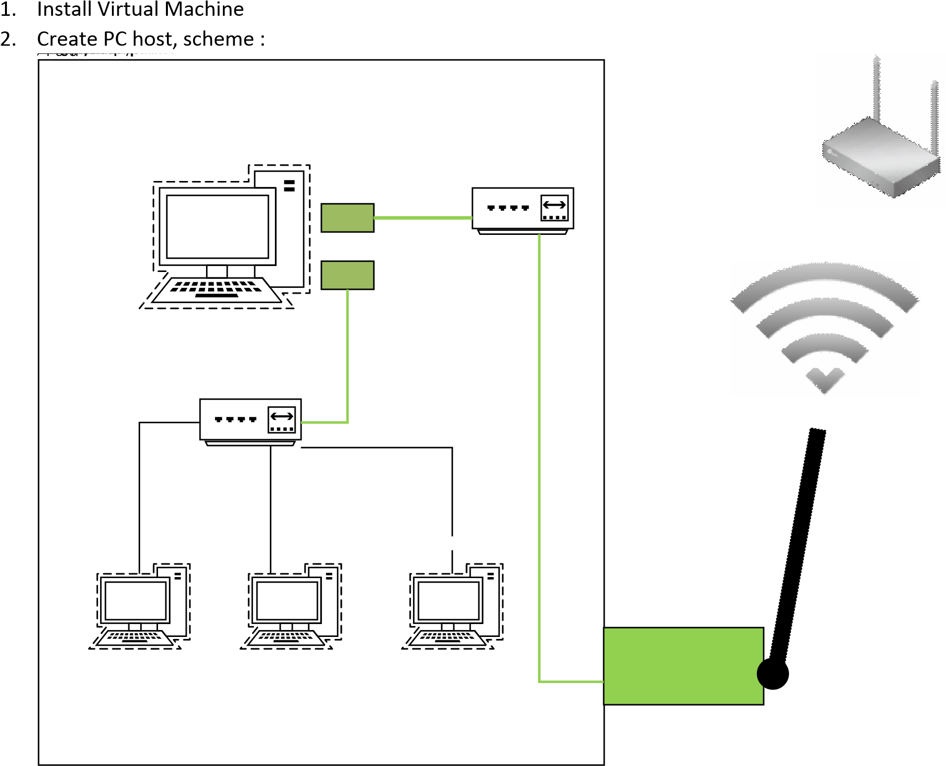

No | Steps | Information
1. | Install Debian
 | Boot : | 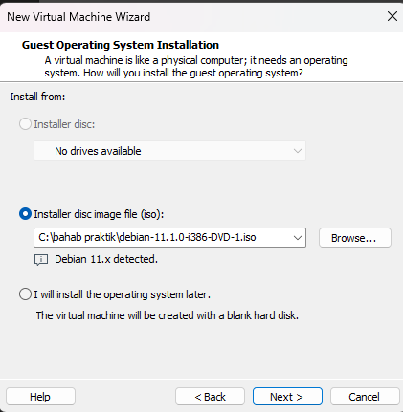
 | Type installation | 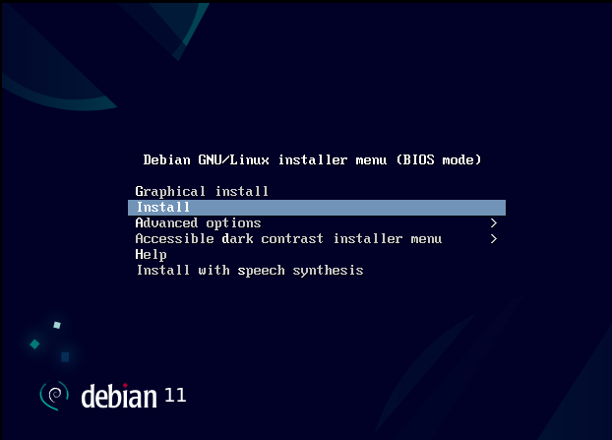
 | Instalasi language | 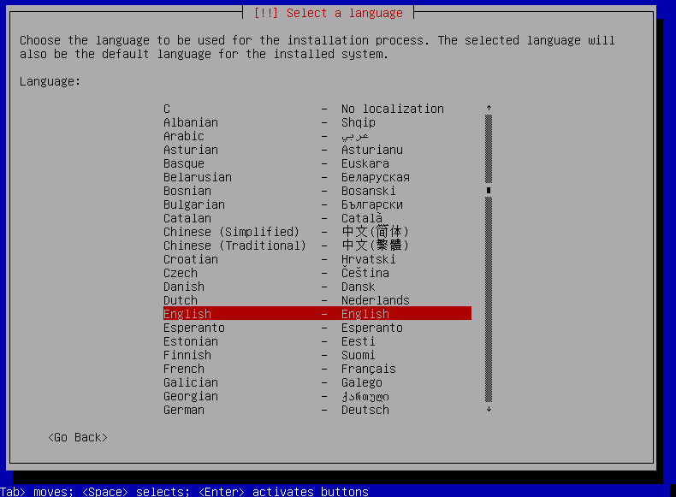
 | your location | 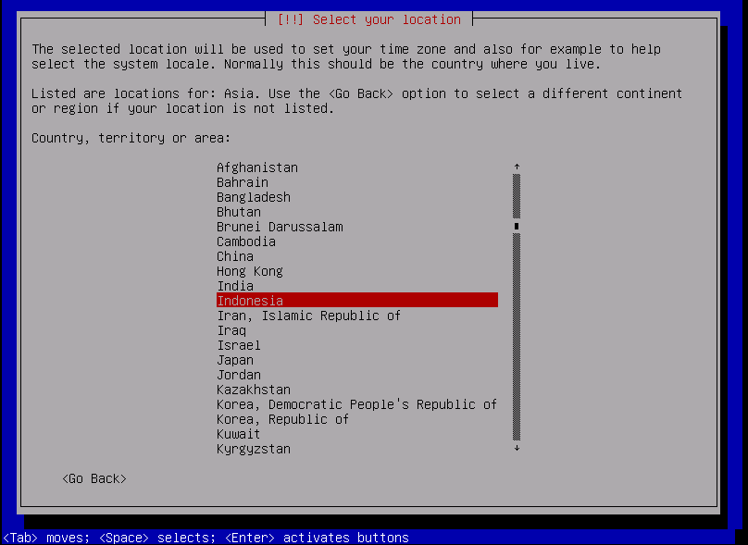
 | keyboard | 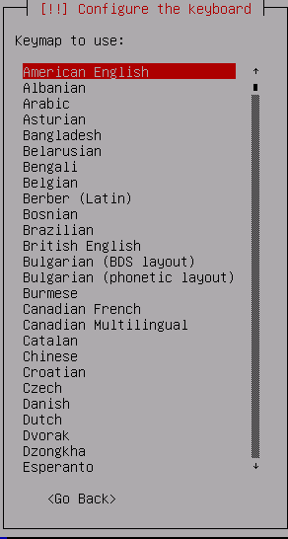.
 | Network | Do not configure thenetwork at this time
 | Hostname | 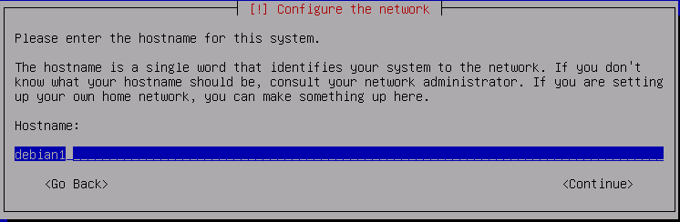
 | Root password | 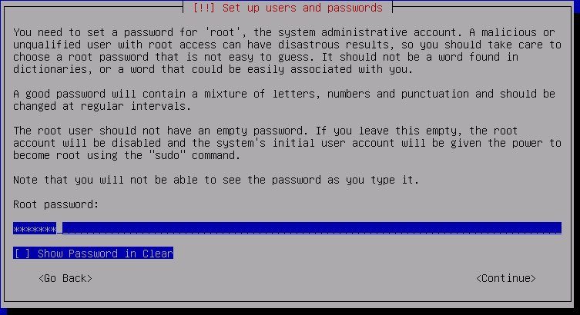
 | Full name for new user | 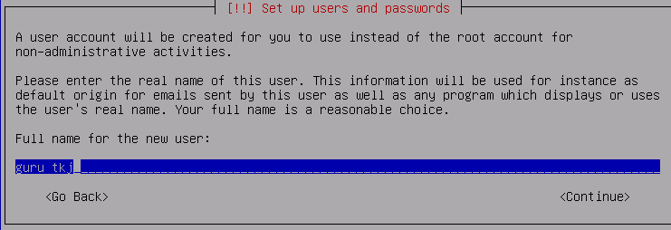
 | Username for your account | 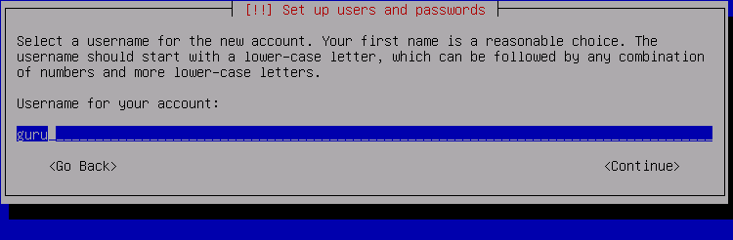
 | Password new user | 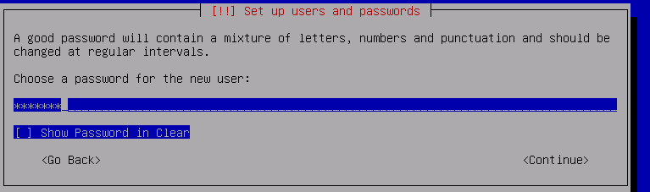
 | Time Zone | 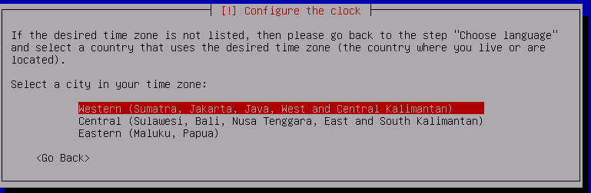
 | Partisi hardisk ( partisi hardisk) | 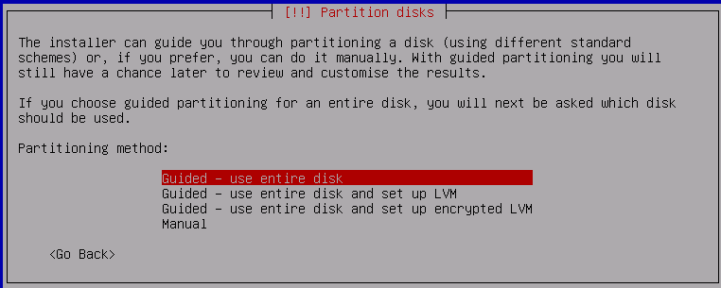
 | Configuration Packet manager. Scan Another CD or DVD | No  Survey : no
 | Software Selection | 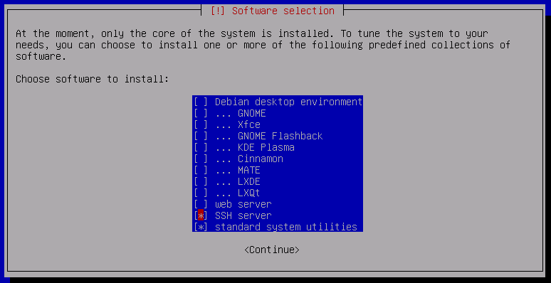
 | install GRUB boot loader on Hardisk : | 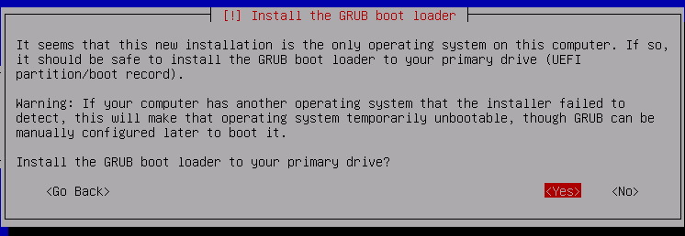  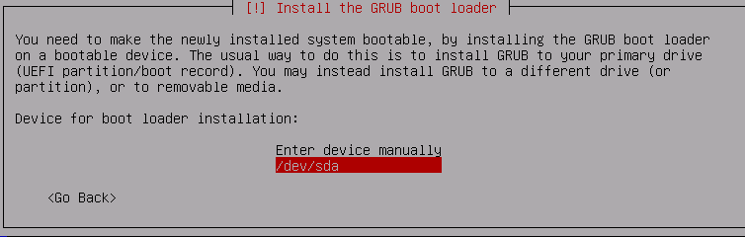
configuration
2. | Login | 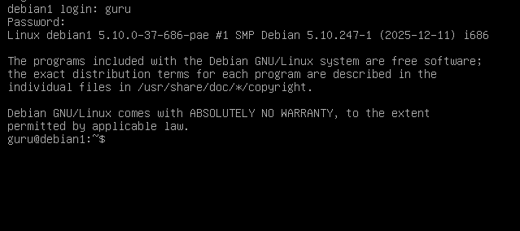
3. | show interfaces | 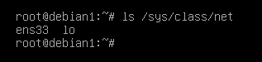
4. | Configure network . | 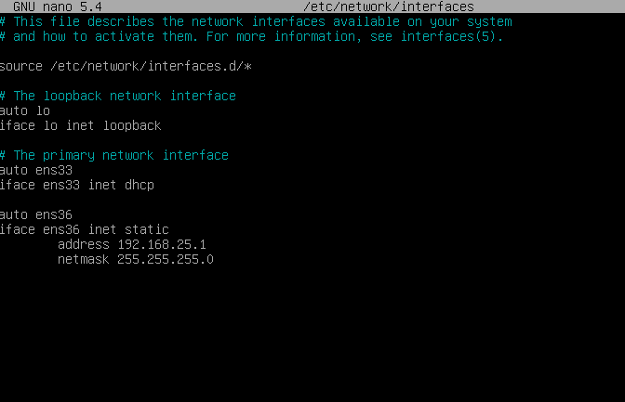
 |  | 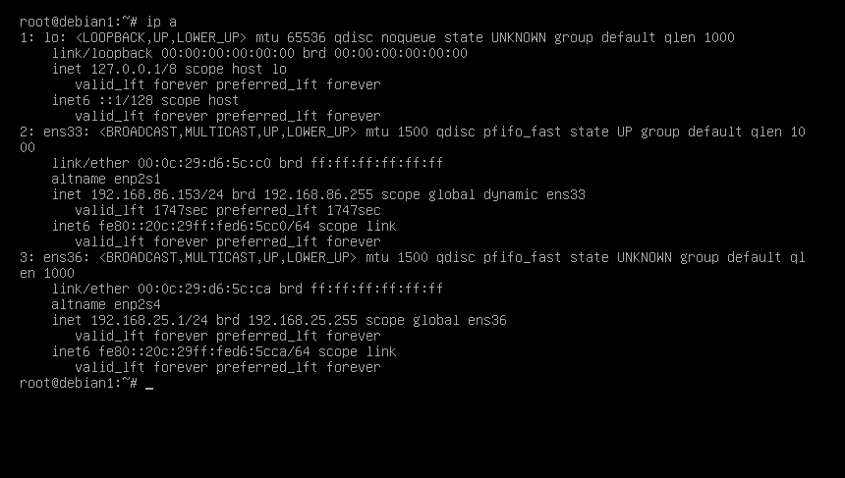--
 |  |  | Note: all | ip | address adapted with your condition

 |  |  | network.
 |  |  | The configuration above is just an example
 |  | Resolv.conf nano /etc/resolv.conf nameserver 172.16.116.1 nameserver 1.1.1.1 nameserver 1.0.0.1 nameserver 114.129.23.33 (disesuaikan jaringan masing )
Ctr x
Save : Y
5. | Check | Ip addr
6. | Repository file | nano /etc/apt/sources.list
 |  | Deactive all repository with #
 |  | 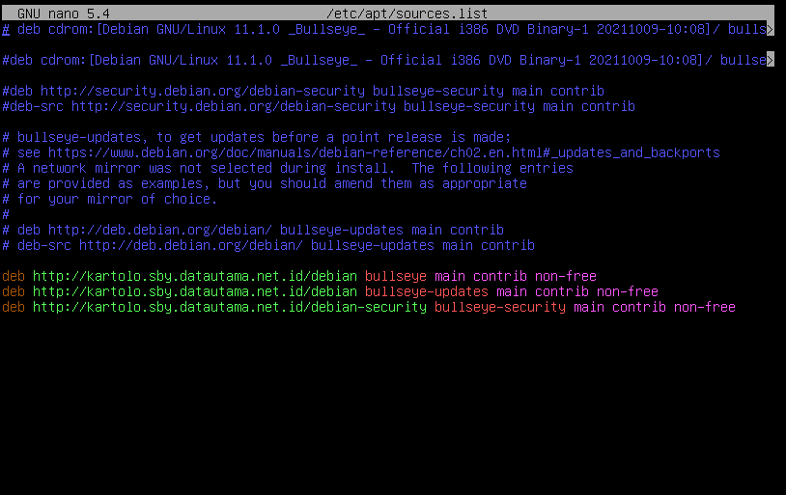
7. | Update debian | 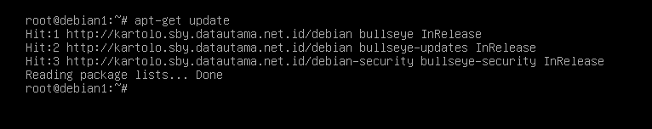
8. | Install ifconfig | 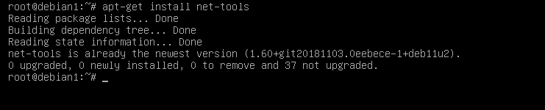
9. | Install iptables | 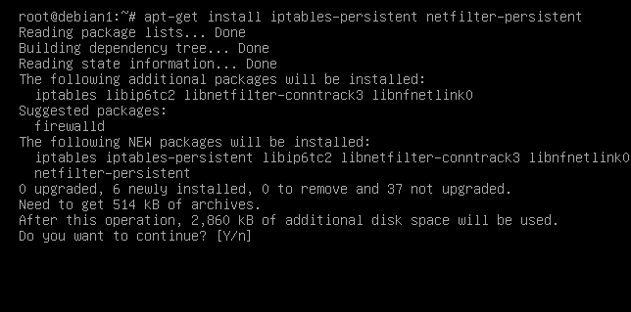
10. | Router Configuration | nano /etc/sysctl.conf
11. |  | 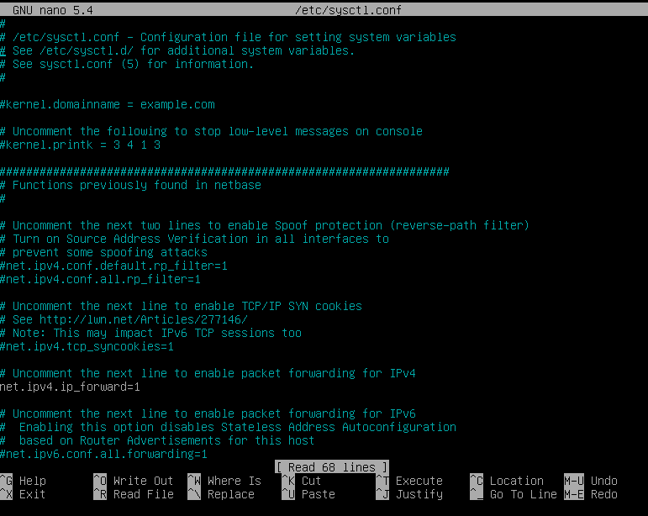
12. |  | nano /proc/sys/net/ipv4/ip_forward
13. |  | 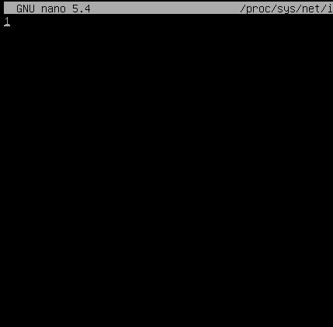
14. | Iptables command | 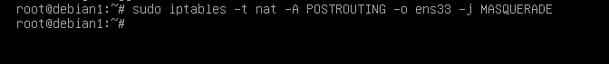
15. | Save iptable | 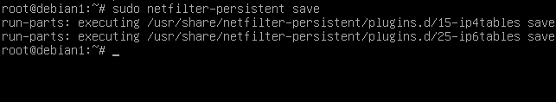
16. | Show location iptables save | 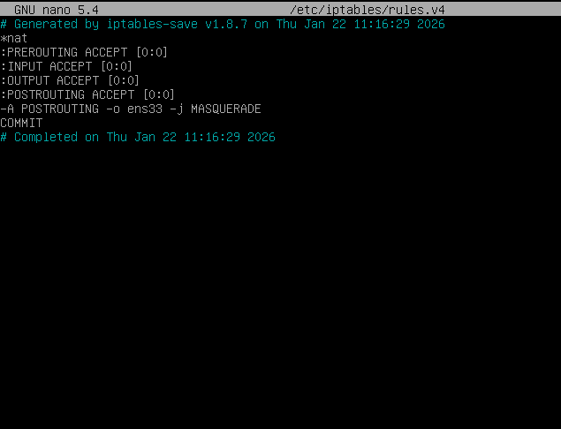

 | Install Debian 10 | 
 | Confifuration
18. | Login | 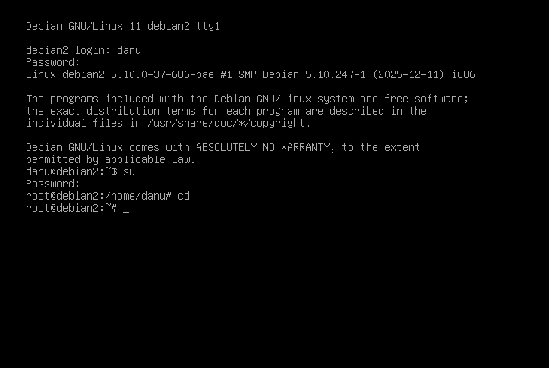
19. | show interfaces | 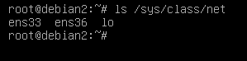
20. | Configure network file | nano /etc/network/interfaces
 |  | 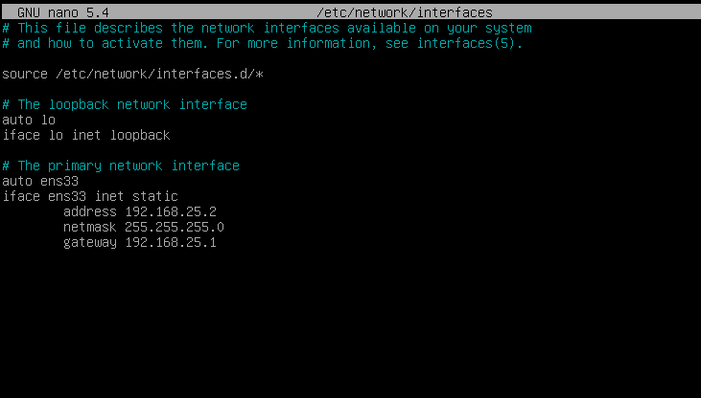
Ctr x
Save : Y
-------------------------------------------------------------Note: all ip address adapted with your condition network.
The configuration above is just an example
21. | Check | Ip addr
22. | Repository file | nano /etc/apt/sources.list
 |  | Deactive all repository with #
 |  | 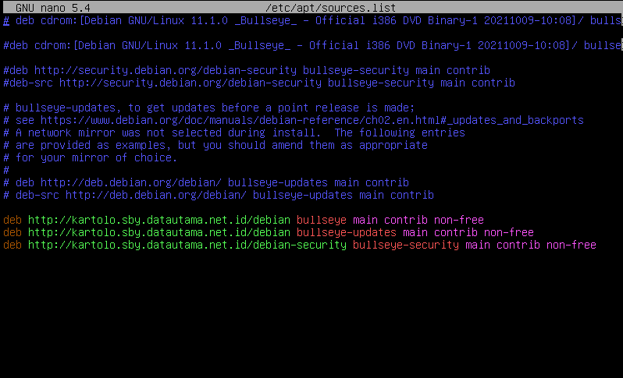
23. | Udate debian | 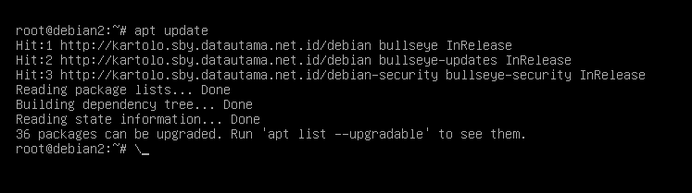
24. | Install ifconfig | 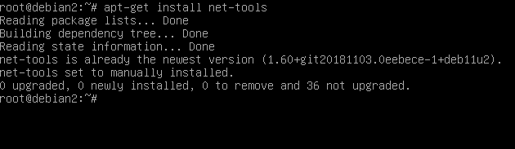
25. | Install http | 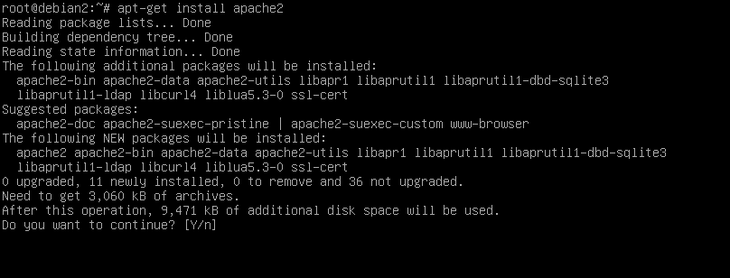* configuration and testing later
26. | Install FTP | 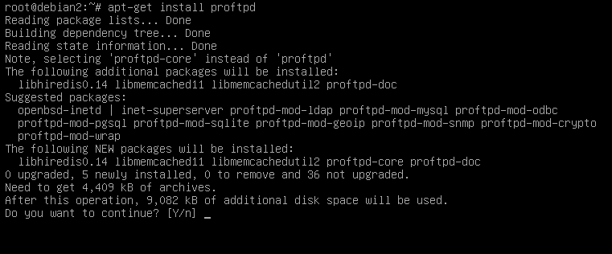
27. | Install Windows XP/windows 7 | 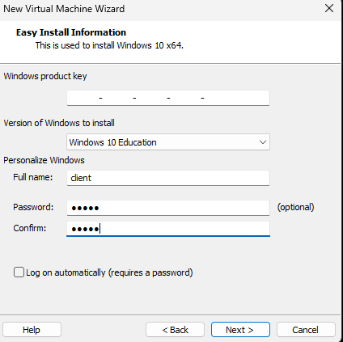
28. | Boot | 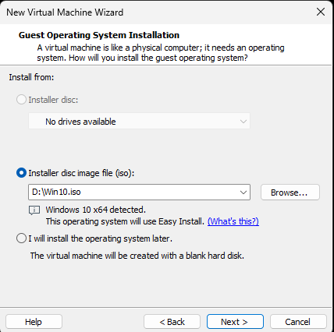
 | Computer Name | Client XP
 | Partition | NTFS single partition, drive C:
 | Username | Client
 | Password | Admin
 | Ip address | 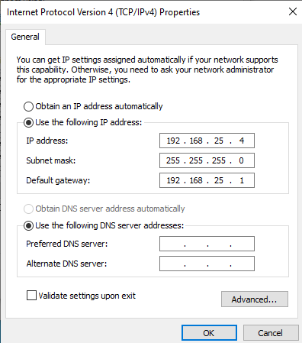

Gateway : 192.168.100.254
Dns : 192.168.1.1 (sesuaikan dengan internet dns , bisa dengan 8.8.8.8)
-------------------------------------------------------Note: all ip address adapted with your condition network.
The configuration above is just an example
29. | Install 10 Kalilinux |  |  |  |  |  |  |  |  |  | 
 | Confifuration
30. | Login |  |  |  |  |  |  |  |  |  | 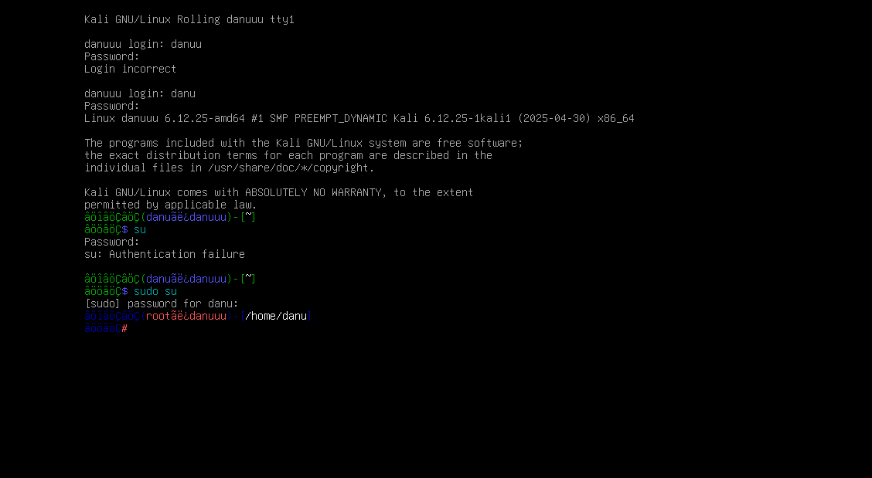
 | show interfaces |  |  |  |  |  |  |  |  |  | 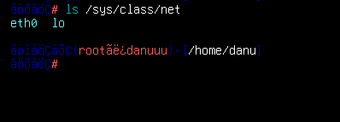
 | Configure network file |  |  |  |  |  |  |  |  |  | nano /etc/network/interfaces
 |  | Note: all | ip | address adapted with your |  |  |  |  |  |  | 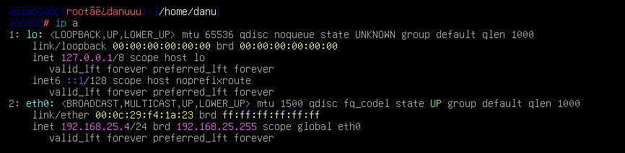
 |  | condition network.
 |  | The configuration above is just an example
31. | Testing NMAP and capture screen your results |  |  |  |  |  |  |  |  |  | 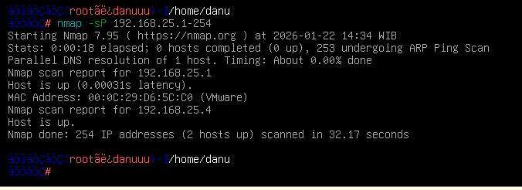
 |  |  |  |  |  |  |  |  |  |  | nmap –sS –A -O 192.168.100.254 nmap –sS –A -O 192.168.100.1 nmap –sS –A -O 192.168.100.2
 |  | All testing |  | adapted with your |  | ip | address
 |  | condition
32. | Paste capture screen in tables belows |  |  |  |  |  |  |  |  |  | Table 2
33. | Upload this file |  |  |  |  |  |  |  |  |  | LMS your account
no
1 | Nmap -sP 192.168.100.1-254 |  |  |  |  |  |  |  |  |  | 
2 | nmap -sS -A -O 192.168.100.254  nmap -sS -A -O 192.168.100.1  Nmap 192.168.100.2 |  |  |  |  |  |  |  |  |  | 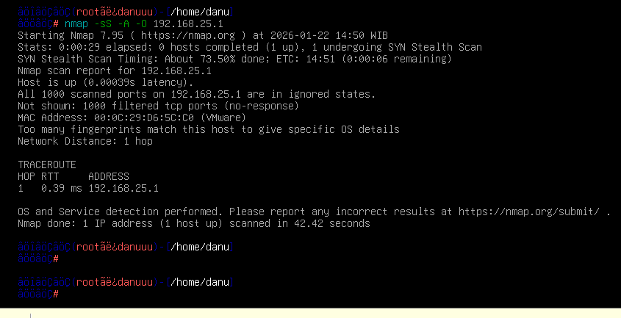  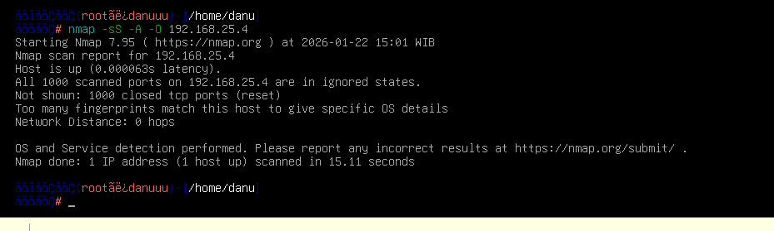
Tabel 2 your result
No
Nmap
explanation
capture screen
1
nmap –sP 192.168.100.1-254
2
nmap –sS –A -O 192.168.100.254
nmap –sS –A -O 192.168.100.1 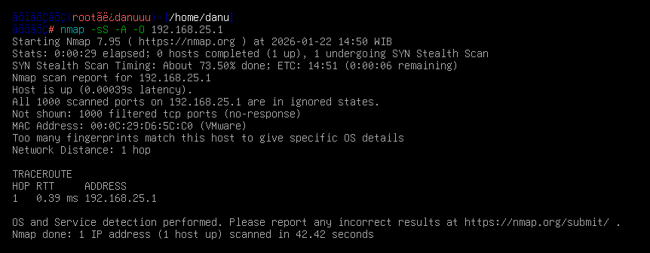
nmap –sS –A -O 192.168.100.2
**
Note change with your
ip
address con
dition

